Before Lts-

Create curl -

curl --location 'https://niuatt.niua.in/pet-services/pet-registration/_create' \
--header 'sec-ch-ua-platform: "macOS"' \
--header 'Referer: https://niuatt.niua.in/upyog-ui/citizen/ptr/petservice/new-application/acknowledgement' \
--header 'User-Agent: Mozilla/5.0 (Macintosh; Intel Mac OS X 10_15_7) AppleWebKit/537.36 (KHTML, like Gecko) Chrome/139.0.0.0 Safari/537.36' \
--header 'Accept: application/json, text/plain, */*' \
--header 'sec-ch-ua: "Not;A=Brand";v="99", "Google Chrome";v="139", "Chromium";v="139"' \
--header 'Content-Type: application/json;charset=UTF-8' \
--header 'sec-ch-ua-mobile: ?0' \
--data-raw '{
"PetRegistrationApplications": [
{
"tenantId": "pg.citya",
"applicantName": "sma",
"mobileNumber": "9999999999",
"alternateNumber": "",
"fatherName": "asgsgfdfg",
"emailId": "dgdsf@gmail.com",
"applicationType": "NEWAPPLICATION",
"validityDate": null,
"status": null,
"expireflag": false,
"petToken": "",
"previousapplicationnumber": null,
"address": {
"pincode": "112233",
"landmark": "sfdgsd",
"city": "New Delhi",
"doorNo": "345",
"street": "sfsdfg",
"locality": {
"code": "Main Road Abadpura"
},
"buildingName": "dfsgdf",
"addressLine1": "sdgsdf",
"addressLine2": "sfgsdg"
},
"petDetails": {
"petType": "Dog",
"breedType": "Labrador Retriever",
"petGender": "MALE",
"birthDate": 1751999399000,
"adoptionDate": null,
"identificationMark": "sfgsd",
"petColor": "2",
"clinicName": "sdfas",
"petName": "sfgsd",
"doctorName": "sds",
"lastVaccineDate": "2025-08-14",
"petAge": 2,
"vaccinationNumber": "43534345"
},
"documents": [
{
"documentType": "OWNER.IDENTITYPROOF.AADHAAR",
"filestoreId": "b0739198-61d0-46f6-b045-c1f2f7dc5739",
"documentUid": "b0739198-61d0-46f6-b045-c1f2f7dc5739"
},
{
"documentType": "OWNER.OWNERPHOTO",
"filestoreId": "24548d76-e4f4-4361-abba-8d51444b2cb3",
"documentUid": "24548d76-e4f4-4361-abba-8d51444b2cb3"
},
{
"documentType": "PET.VACCINATIONCERTIFICATE",
"filestoreId": "7716975c-6869-452b-a4fb-da1e2999da92",
"documentUid": "7716975c-6869-452b-a4fb-da1e2999da92"
},
{
"documentType": "PET.PETPHOTO",
"filestoreId": "43a48492-a92c-4de4-a277-3834c5bf87a1",
"documentUid": "43a48492-a92c-4de4-a277-3834c5bf87a1"
},
{
"documentType": "PET.FITNESSCERTIFICATE",
"filestoreId": "a67ce695-e101-4d83-85b2-70c04ca4eeff",
"documentUid": "a67ce695-e101-4d83-85b2-70c04ca4eeff"
}
],
"propertyId": "345345",
"workflow": {
"businessService": "ptr",
"action": "APPLY",
"moduleName": "pet-services"
}
}
],
"RequestInfo": {
"apiId": "Rainmaker",
"authToken": "3cd10e2d-e31e-4848-a579-06e0b789c59a",
"userInfo": {
"id": 893,
"uuid": "1d19970b-e1c7-46dd-a554-d2353a2c2965",
"userName": "9999999999",
"name": "sma",
"mobileNumber": "9999999999",
"emailId": null,
"locale": null,
"type": "CITIZEN",
"roles": [
{
"name": "Citizen",
"code": "CITIZEN",
"tenantId": "pg"
}
],
"active": true,
"tenantId": "pg",
"permanentCity": null
},
"msgId": "1757315437005|en_IN",
"plainAccessRequest": {}
}
}'

Response -

{
"ResponseInfo": {
"apiId": "Rainmaker",
"ver": null,
"ts": null,
"resMsgId": "uief87324",
"msgId": "1757315437005|en_IN",
"status": "successful"
},
"PetRegistrationApplications": [
{
"renewalAuditDetails": null,
"id": "c5a26a3c-1d16-4a75-8a9e-be12e40e75aa",
"tenantId": "pg.citya",
"applicationNumber": "PG-PTR-2025-09-08-000279",
"applicantName": "sma",
"fatherName": "asgsgfdfg",
"mobileNumber": "9999999999",
"emailId": "dgdsf@gmail.com",
"address": {
"id": "37637c84-e075-41eb-8627-05fd57131a17",
"tenantId": null,
"registrationId": "c5a26a3c-1d16-4a75-8a9e-be12e40e75aa",
"doorNo": "345",
"latitude": null,
"longitude": null,
"addressId": null,
"addressNumber": null,
"type": null,
"addressLine1": "sdgsdf",
"addressLine2": "sfgsdg",
"landmark": "sfdgsd",
"city": "New Delhi",
"pincode": "112233",
"detail": null,
"buildingName": "dfsgdf",
"street": "sfsdfg",
"locality": {
"code": "Main Road Abadpura",
"name": null,
"label": null,
"latitude": null,
"longitude": null,
"children": null,
"materializedPath": null
}
},
"auditDetails": {
"createdBy": "1d19970b-e1c7-46dd-a554-d2353a2c2965",
"lastModifiedBy": "1d19970b-e1c7-46dd-a554-d2353a2c2965",
"createdTime": 1757315599173,
"lastModifiedTime": 1757315599173
},
"petDetails": {
"id": "9bbaa156-db74-44b6-b70f-86b38682f058",
"petDetailsId": "c5a26a3c-1d16-4a75-8a9e-be12e40e75aa",
"petName": "sfgsd",
"petType": "Dog",
"breedType": "Labrador Retriever",
"petAge": "2",
"petGender": "MALE",
"clinicName": "sdfas",
"doctorName": "sds",
"lastVaccineDate": "2025-08-14",
"vaccinationNumber": "43534345",
"petColor": "2",
"adoptionDate": null,
"birthDate": 1751999399000,
"identificationMark": "sfgsd"
},
"applicationType": "NEWAPPLICATION",
"validityDate": 1774981740,
"status": "APPLIED",
"expireFlag": false,
"petToken": "",
"previousApplicationNumber": null,
"propertyId": "345345",
"documents": [
{
"id": "12cba715-83c1-4953-a47b-c44b6bae2ce4",
"active": true,
"tenantId": "pg.citya",
"documentType": "OWNER.IDENTITYPROOF.AADHAAR",
"filestoreId": "b0739198-61d0-46f6-b045-c1f2f7dc5739",
"documentUid": "b0739198-61d0-46f6-b045-c1f2f7dc5739",
"auditDetails": {
"createdBy": "1d19970b-e1c7-46dd-a554-d2353a2c2965",
"lastModifiedBy": "1d19970b-e1c7-46dd-a554-d2353a2c2965",
"createdTime": 1757315599173,
"lastModifiedTime": 1757315599173
}
},
{
"id": "feab16fd-7f79-49d3-9756-d5d7a648bfdb",
"active": true,
"tenantId": "pg.citya",
"documentType": "OWNER.OWNERPHOTO",
"filestoreId": "24548d76-e4f4-4361-abba-8d51444b2cb3",
"documentUid": "24548d76-e4f4-4361-abba-8d51444b2cb3",
"auditDetails": {
"createdBy": "1d19970b-e1c7-46dd-a554-d2353a2c2965",
"lastModifiedBy": "1d19970b-e1c7-46dd-a554-d2353a2c2965",
"createdTime": 1757315599173,
"lastModifiedTime": 1757315599173
}
},
{
"id": "dbc6f634-08f1-4af4-888c-08b8e17cfb40",
"active": true,
"tenantId": "pg.citya",
"documentType": "PET.VACCINATIONCERTIFICATE",
"filestoreId": "7716975c-6869-452b-a4fb-da1e2999da92",
"documentUid": "7716975c-6869-452b-a4fb-da1e2999da92",
"auditDetails": {
"createdBy": "1d19970b-e1c7-46dd-a554-d2353a2c2965",
"lastModifiedBy": "1d19970b-e1c7-46dd-a554-d2353a2c2965",
"createdTime": 1757315599173,
"lastModifiedTime": 1757315599173
}
},
{
"id": "68262db8-3dfc-4443-be96-aa819376109d",
"active": true,
"tenantId": "pg.citya",
"documentType": "PET.PETPHOTO",
"filestoreId": "43a48492-a92c-4de4-a277-3834c5bf87a1",
"documentUid": "43a48492-a92c-4de4-a277-3834c5bf87a1",
"auditDetails": {
"createdBy": "1d19970b-e1c7-46dd-a554-d2353a2c2965",
"lastModifiedBy": "1d19970b-e1c7-46dd-a554-d2353a2c2965",
"createdTime": 1757315599173,
"lastModifiedTime": 1757315599173
}
},
{
"id": "fcffb1e0-8a2d-4220-bac4-e069f31e2f7f",
"active": true,
"tenantId": "pg.citya",
"documentType": "PET.FITNESSCERTIFICATE",
"filestoreId": "a67ce695-e101-4d83-85b2-70c04ca4eeff",
"documentUid": "a67ce695-e101-4d83-85b2-70c04ca4eeff",
"auditDetails": {
"createdBy": "1d19970b-e1c7-46dd-a554-d2353a2c2965",
"lastModifiedBy": "1d19970b-e1c7-46dd-a554-d2353a2c2965",
"createdTime": 1757315599173,
"lastModifiedTime": 1757315599173
}
}
],
"workflow": {
"action": "APPLY",
"status": null,
"comments": null,
"assignes": null,
"documents": null
}
}
]
}

After Lts -

Create curl -
curl --location 'http://localhost:8087/pet-services/pet-registration/_create' \
--header 'Accept: application/json, text/plain, */*' \
--header 'Accept-Language: en-GB,en-US;q=0.9,en;q=0.8' \
--header 'Connection: keep-alive' \
--header 'Content-Type: application/json;charset=UTF-8' \
--header 'Origin: http://localhost:3000' \
--header 'Referer: http://localhost:3000/digit-ui/citizen/ptr/petservice/new-application/acknowledgement' \
--header 'Sec-Fetch-Dest: empty' \
--header 'Sec-Fetch-Mode: cors' \
--header 'Sec-Fetch-Site: same-origin' \
--header 'User-Agent: Mozilla/5.0 (Macintosh; Intel Mac OS X 10_15_7) AppleWebKit/537.36 (KHTML, like Gecko) Chrome/139.0.0.0 Safari/537.36' \
--header 'sec-ch-ua: "Not;A=Brand";v="99", "Google Chrome";v="139", "Chromium";v="139"' \
--header 'sec-ch-ua-mobile: ?0' \
--header 'sec-ch-ua-platform: "macOS"' \
--data-raw '{
"PetRegistrationApplications": [
{
"tenantId": "pg.citya",
"applicantName": "wrtert",
"mobileNumber": "9999999999",
"alternateNumber": "",
"fatherName": "rtewet",
"emailId": "sdsg@gmail.com",
"applicationType": "NEWAPPLICATION",
"validityDate": null,
"status": null,
"expireflag": false,
"petToken": "",
"previousapplicationnumber": null,
"address": {
"pincode": "112233",
"landmark": "sfg",
"city": "New Delhi",
"doorNo": "345",
"street": "dfgs",
"locality": {
"code": "Main Road Abadpura"
},
"buildingName": "dfgsdf",
"addressLine1": "dfsg",
"addressLine2": "sfg"
},
"petDetails": {
"petType": "Cat",
"breedType": "Bombay Cat",
"petGender": "MALE",
"birthDate": 1752085799000,
"adoptionDate": null,
"identificationMark": "dfgs",
"petColor": "18",
"clinicName": "dgd",
"petName": "sadgsdfg",
"doctorName": "sfgs",
"lastVaccineDate": "2025-08-11",
"petAge": 2,
"vaccinationNumber": "s45345"
},
"documents": [
{
"documentType": "OWNER.IDENTITYPROOF.AADHAAR",
"filestoreId": "276fd54f-b5d8-4cea-b9e4-2209598af227",
"documentUid": "276fd54f-b5d8-4cea-b9e4-2209598af227"
},
{
"documentType": "OWNER.OWNERPHOTO",
"filestoreId": "457055ef-0861-471d-b188-7cfb638c7170",
"documentUid": "457055ef-0861-471d-b188-7cfb638c7170"
},
{
"documentType": "PET.VACCINATIONCERTIFICATE",
"filestoreId": "b3ea9ec9-51b2-44bf-a003-8090f3d738d1",
"documentUid": "b3ea9ec9-51b2-44bf-a003-8090f3d738d1"
},
{
"documentType": "PET.PETPHOTO",
"filestoreId": "9b324534-987a-4f87-b206-8e9ea9db7656",
"documentUid": "9b324534-987a-4f87-b206-8e9ea9db7656"
},
{
"documentType": "PET.FITNESSCERTIFICATE",
"filestoreId": "b1f8a91e-d1cb-43fb-9880-ed87304f7075",
"documentUid": "b1f8a91e-d1cb-43fb-9880-ed87304f7075"
}
],
"propertyId": "45353",
"workflow": {
"businessService": "ptr",
"action": "APPLY",
"moduleName": "pet-services"
}
}
],
"RequestInfo": {
"apiId": "Rainmaker",
"authToken": "bd98f73e-624d-4388-8a9f-e0e1702e1f9c",
"userInfo": {
"id": 4031,
"uuid": "8ddbbdba-5ce1-4cbd-83a4-c8236f95766e",
"userName": "PETEMP",
"name": "PETEMP",
"mobileNumber": "9586868696",
"emailId": null,
"locale": null,
"type": "EMPLOYEE",
"roles": [
{
"name": "Pet Counter Employee",
"code": "PTR_CEMP",
"tenantId": "pg.citya"
},
{
"name": "Pet Document Verifier",
"code": "PTR_VERIFIER",
"tenantId": "pg.citya"
},
{
"name": "Pet Approver",
"code": "PTR_APPROVER",
"tenantId": "pg.citya"
}
],
"active": true,
"tenantId": "pg.citya",
"permanentCity": null
},
"msgId": "1756964230011|en_IN",
"plainAccessRequest": {}
}
}'

Response -

{
"ResponseInfo": {
"apiId": "Rainmaker",
"ver": null,
"ts": null,
"resMsgId": "uief87324",
"msgId": "1756964230011|en_IN",
"status": "successful"
},
"PetRegistrationApplications": [
{
"renewalAuditDetails": null,
"id": "bf8acf20-229f-4ec4-9d92-28b9349a011c",
"tenantId": "pg.citya",
"applicationNumber": "PG-PTR-2025-09-04-000273",
"applicantName": "wrtert",
"fatherName": "rtewet",
"mobileNumber": "9999999999",
"emailId": "sdsg@gmail.com",
"address": {
"id": "8312e54b-f738-4346-8a02-c2b253bee6ad",
"tenantId": null,
"registrationId": "bf8acf20-229f-4ec4-9d92-28b9349a011c",
"doorNo": "345",
"latitude": null,
"longitude": null,
"addressId": null,
"addressNumber": null,
"type": null,
"addressLine1": "dfsg",
"addressLine2": "sfg",
"landmark": "sfg",
"city": "New Delhi",
"pincode": "112233",
"detail": null,
"buildingName": "dfgsdf",
"street": "dfgs",
"locality": {
"code": "Main Road Abadpura",
"name": null,
"label": null,
"latitude": null,
"longitude": null,
"children": null,
"materializedPath": null
}
},
"auditDetails": {
"createdBy": "8ddbbdba-5ce1-4cbd-83a4-c8236f95766e",
"lastModifiedBy": "8ddbbdba-5ce1-4cbd-83a4-c8236f95766e",
"createdTime": 1756969462759,
"lastModifiedTime": 1756969462759
},
"petDetails": {
"id": "a9541dab-be78-4f07-8ba6-62ba5a94702e",
"petDetailsId": "bf8acf20-229f-4ec4-9d92-28b9349a011c",
"petName": "sadgsdfg",
"petType": "Cat",
"breedType": "Bombay Cat",
"petAge": "2",
"petGender": "MALE",
"clinicName": "dgd",
"doctorName": "sfgs",
"lastVaccineDate": "2025-08-11",
"vaccinationNumber": "s45345",
"petColor": "18",
"adoptionDate": null,
"birthDate": 1752085799000,
"identificationMark": "dfgs"
},
"applicationType": "NEWAPPLICATION",
"validityDate": 1775001540,
"status": "APPLIED",
"expireFlag": false,
"petToken": "",
"previousApplicationNumber": null,
"propertyId": "45353",
"documents": [
{
"id": "61b169a9-5b15-425a-baf4-86790c90d1d9",
"active": true,
"tenantId": "pg.citya",
"documentType": "OWNER.IDENTITYPROOF.AADHAAR",
"filestoreId": "276fd54f-b5d8-4cea-b9e4-2209598af227",
"documentUid": "276fd54f-b5d8-4cea-b9e4-2209598af227",
"auditDetails": {
"createdBy": "8ddbbdba-5ce1-4cbd-83a4-c8236f95766e",
"lastModifiedBy": "8ddbbdba-5ce1-4cbd-83a4-c8236f95766e",
"createdTime": 1756969462759,
"lastModifiedTime": 1756969462759
}
},
{
"id": "6b0d3fff-373f-47b9-947b-9e65f0e65a21",
"active": true,
"tenantId": "pg.citya",
"documentType": "OWNER.OWNERPHOTO",
"filestoreId": "457055ef-0861-471d-b188-7cfb638c7170",
"documentUid": "457055ef-0861-471d-b188-7cfb638c7170",
"auditDetails": {
"createdBy": "8ddbbdba-5ce1-4cbd-83a4-c8236f95766e",
"lastModifiedBy": "8ddbbdba-5ce1-4cbd-83a4-c8236f95766e",
"createdTime": 1756969462759,
"lastModifiedTime": 1756969462759
}
},
{
"id": "8fa167ad-81c9-452d-8288-2af1c05dcce5",
"active": true,
"tenantId": "pg.citya",
"documentType": "PET.VACCINATIONCERTIFICATE",
"filestoreId": "b3ea9ec9-51b2-44bf-a003-8090f3d738d1",
"documentUid": "b3ea9ec9-51b2-44bf-a003-8090f3d738d1",
"auditDetails": {
"createdBy": "8ddbbdba-5ce1-4cbd-83a4-c8236f95766e",
"lastModifiedBy": "8ddbbdba-5ce1-4cbd-83a4-c8236f95766e",
"createdTime": 1756969462759,
"lastModifiedTime": 1756969462759
}
},
{
"id": "6f4981b7-acb0-461b-8138-4b51cbed71fb",
"active": true,
"tenantId": "pg.citya",
"documentType": "PET.PETPHOTO",
"filestoreId": "9b324534-987a-4f87-b206-8e9ea9db7656",
"documentUid": "9b324534-987a-4f87-b206-8e9ea9db7656",
"auditDetails": {
"createdBy": "8ddbbdba-5ce1-4cbd-83a4-c8236f95766e",
"lastModifiedBy": "8ddbbdba-5ce1-4cbd-83a4-c8236f95766e",
"createdTime": 1756969462759,
"lastModifiedTime": 1756969462759
}
},
{
"id": "2b98c8bb-b107-4fbf-a9ba-2a48829b22ed",
"active": true,
"tenantId": "pg.citya",
"documentType": "PET.FITNESSCERTIFICATE",
"filestoreId": "b1f8a91e-d1cb-43fb-9880-ed87304f7075",
"documentUid": "b1f8a91e-d1cb-43fb-9880-ed87304f7075",
"auditDetails": {
"createdBy": "8ddbbdba-5ce1-4cbd-83a4-c8236f95766e",
"lastModifiedBy": "8ddbbdba-5ce1-4cbd-83a4-c8236f95766e",
"createdTime": 1756969462759,
"lastModifiedTime": 1756969462759
}
}
],
"workflow": {
"action": "APPLY",
"status": null,
"comments": null,
"assignes": null,
"documents": null
}
}
]
}

Postman-
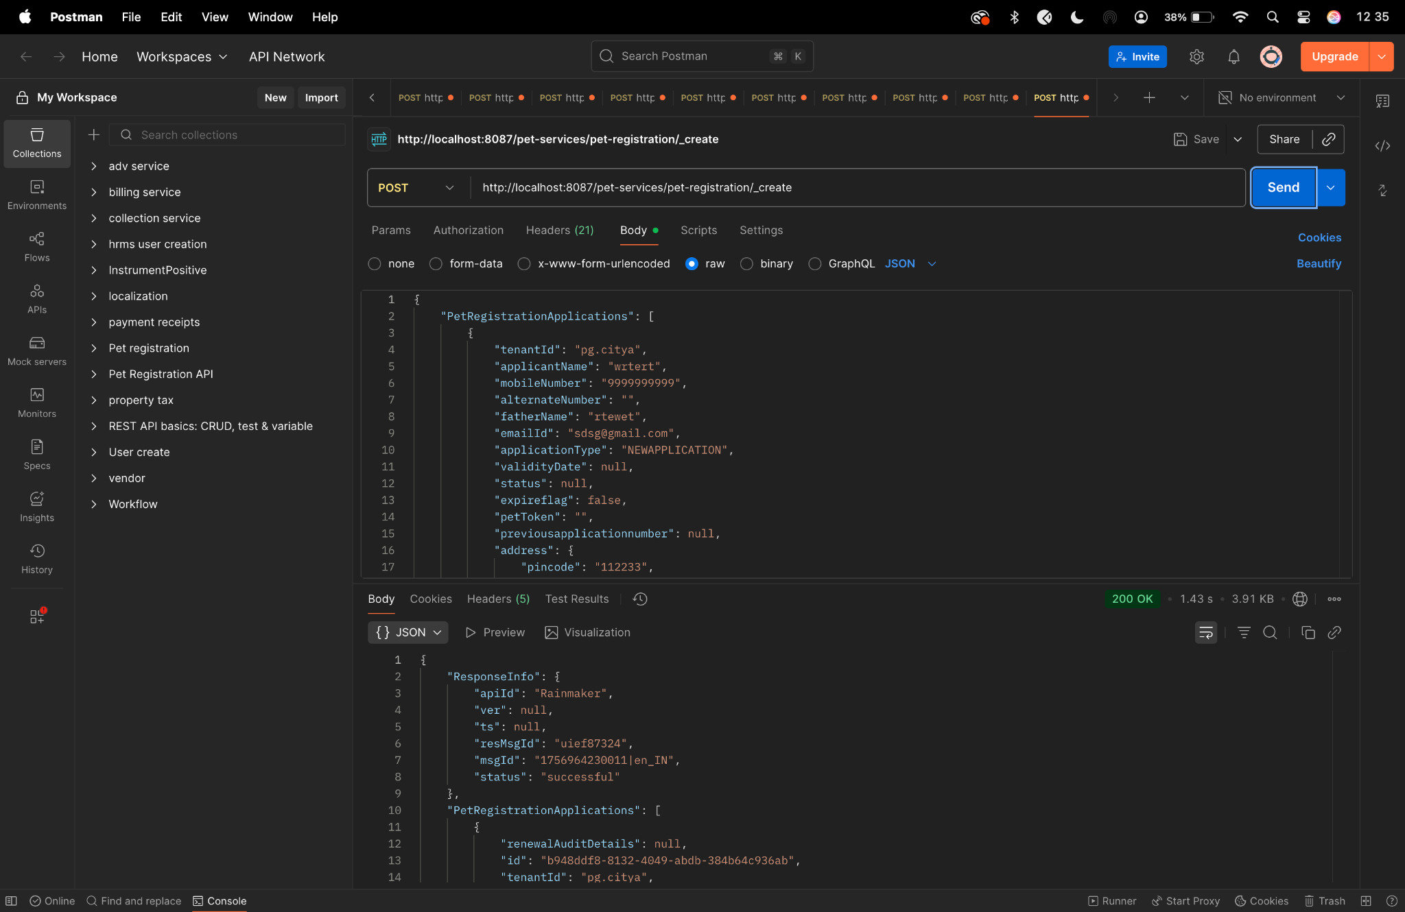

Diff checker -
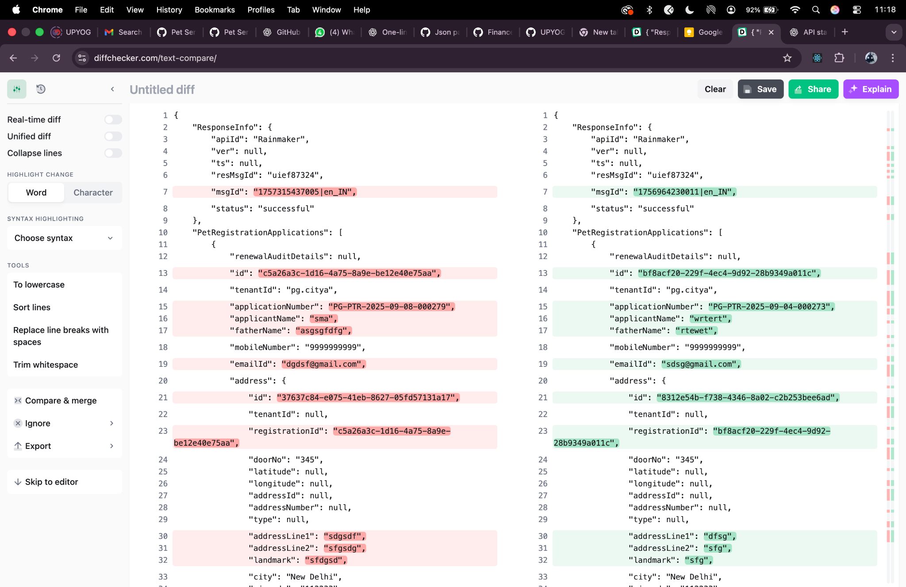

Before lts -

Update Curl-

curl --location 'https://niuatt.niua.in/pet-services/pet-registration/_update' \
--header 'accept: application/json, text/plain, */*' \
--header 'accept-language: en-GB,en-US;q=0.9,en;q=0.8' \
--header 'content-type: application/json;charset=UTF-8' \
--header 'origin: https://niuatt.niua.in' \
--header 'priority: u=1, i' \
--header 'referer: https://niuatt.niua.in/digit-ui/employee/ptr/petservice/application-details/PG-PTR-2025-09-08-000279' \
--header 'sec-ch-ua: "Not;A=Brand";v="99", "Google Chrome";v="139", "Chromium";v="139"' \
--header 'sec-ch-ua-mobile: ?0' \
--header 'sec-ch-ua-platform: "macOS"' \
--header 'sec-fetch-dest: empty' \
--header 'sec-fetch-mode: cors' \
--header 'sec-fetch-site: same-origin' \
--header 'user-agent: Mozilla/5.0 (Macintosh; Intel Mac OS X 10_15_7) AppleWebKit/537.36 (KHTML, like Gecko) Chrome/139.0.0.0 Safari/537.36' \
--header 'Cookie: _ga=GA1.1.1281085881.1747741867; _clck=1ggqflr%7C2%7Cfyf%7C0%7C1966; _ga_VZ9TNBTB3X=GS2.1.s1755061755$o5$g0$t1755061755$j60$l0$h0; locale=en_IN' \
--data-raw '{
"PetRegistrationApplications": [
{
"renewalAuditDetails": null,
"id": "c5a26a3c-1d16-4a75-8a9e-be12e40e75aa",
"tenantId": "pg.citya",
"applicationNumber": "PG-PTR-2025-09-08-000279",
"applicantName": "sma",
"fatherName": "asgsgfdfg",
"mobileNumber": "9999999999",
"emailId": "dgdsf@gmail.com",
"address": {
"id": "37637c84-e075-41eb-8627-05fd57131a17",
"tenantId": null,
"registrationId": "aregistrationid",
"doorNo": "345",
"latitude": 0,
"longitude": 0,
"addressId": null,
"addressNumber": null,
"type": null,
"addressLine1": "sdgsdf",
"addressLine2": "sfgsdg",
"landmark": "sfdgsd",
"city": "New Delhi",
"pincode": "112233",
"detail": "adetail",
"buildingName": "dfsgdf",
"street": "sfsdfg",
"locality": null
},
"auditDetails": {
"createdBy": "1d19970b-e1c7-46dd-a554-d2353a2c2965",
"lastModifiedBy": "1d19970b-e1c7-46dd-a554-d2353a2c2965",
"createdTime": 1757315599173,
"lastModifiedTime": 1757315599173
},
"petDetails": {
"id": "9bbaa156-db74-44b6-b70f-86b38682f058",
"petDetailsId": null,
"petName": "sfgsd",
"petType": "Dog",
"breedType": "Labrador Retriever",
"petAge": "2",
"petGender": "MALE",
"clinicName": "sdfas",
"doctorName": "sds",
"lastVaccineDate": "2025-08-14",
"vaccinationNumber": "43534345",
"petColor": "2",
"adoptionDate": 0,
"birthDate": 1751999399000,
"identificationMark": "sfgsd"
},
"applicationType": "NEWAPPLICATION",
"validityDate": 1774981740,
"status": "APPLIED",
"expireFlag": false,
"petToken": "",
"previousApplicationNumber": null,
"propertyId": "345345",
"documents": [
{
"id": "12cba715-83c1-4953-a47b-c44b6bae2ce4",
"active": null,
"tenantId": null,
"documentType": "OWNER.IDENTITYPROOF.AADHAAR",
"filestoreId": "b0739198-61d0-46f6-b045-c1f2f7dc5739",
"documentUid": "b0739198-61d0-46f6-b045-c1f2f7dc5739",
"auditDetails": null
},
{
"id": "feab16fd-7f79-49d3-9756-d5d7a648bfdb",
"active": null,
"tenantId": null,
"documentType": "OWNER.OWNERPHOTO",
"filestoreId": "24548d76-e4f4-4361-abba-8d51444b2cb3",
"documentUid": "24548d76-e4f4-4361-abba-8d51444b2cb3",
"auditDetails": null
},
{
"id": "dbc6f634-08f1-4af4-888c-08b8e17cfb40",
"active": null,
"tenantId": null,
"documentType": "PET.VACCINATIONCERTIFICATE",
"filestoreId": "7716975c-6869-452b-a4fb-da1e2999da92",
"documentUid": "7716975c-6869-452b-a4fb-da1e2999da92",
"auditDetails": null
},
{
"id": "68262db8-3dfc-4443-be96-aa819376109d",
"active": null,
"tenantId": null,
"documentType": "PET.PETPHOTO",
"filestoreId": "43a48492-a92c-4de4-a277-3834c5bf87a1",
"documentUid": "43a48492-a92c-4de4-a277-3834c5bf87a1",
"auditDetails": null
},
{
"id": "fcffb1e0-8a2d-4220-bac4-e069f31e2f7f",
"active": null,
"tenantId": null,
"documentType": "PET.FITNESSCERTIFICATE",
"filestoreId": "a67ce695-e101-4d83-85b2-70c04ca4eeff",
"documentUid": "a67ce695-e101-4d83-85b2-70c04ca4eeff",
"auditDetails": null
}
],
"workflow": {
"action": "APPROVE",
"comments": "sdgdfgdfg",
"businessService": "ptr",
"moduleName": "pet-services"
}
}
],
"RequestInfo": {
"apiId": "Rainmaker",
"authToken": "9284ecf8-6686-47d2-8879-b0e137b324c2",
"userInfo": {
"id": 786,
"uuid": "4b662cf9-18d8-43fb-a532-a955104dd2f8",
"userName": "PET_CEMP",
"name": "Pet",
"mobileNumber": "9810010169",
"emailId": null,
"locale": null,
"type": "EMPLOYEE",
"roles": [
{
"name": "Employee",
"code": "EMPLOYEE",
"tenantId": "pg.citya"
},
{
"name": "Pet Counter Employee",
"code": "PTR_CEMP",
"tenantId": "pg.citya"
},
{
"name": "Pet Document Verifier",
"code": "PTR_VERIFIER",
"tenantId": "pg.citya"
},
{
"name": "Pet Approver",
"code": "PTR_APPROVER",
"tenantId": "pg.citya"
}
],
"active": true,
"tenantId": "pg.citya",
"permanentCity": null
},
"msgId": "1757316298760|en_IN",
"plainAccessRequest": {}
}
}'

Response -

{
"ResponseInfo": {
"apiId": "Rainmaker",
"ver": null,
"ts": null,
"resMsgId": "uief87324",
"msgId": "1757316298760|en_IN",
"status": "successful"
},
"PetRegistrationApplications": [
{
"renewalAuditDetails": null,
"id": "c5a26a3c-1d16-4a75-8a9e-be12e40e75aa",
"tenantId": "pg.citya",
"applicationNumber": "PG-PTR-2025-09-08-000279",
"applicantName": "sma",
"fatherName": "asgsgfdfg",
"mobileNumber": "9999999999",
"emailId": "dgdsf@gmail.com",
"address": {
"id": "37637c84-e075-41eb-8627-05fd57131a17",
"tenantId": null,
"registrationId": "aregistrationid",
"doorNo": "345",
"latitude": 0.0,
"longitude": 0.0,
"addressId": null,
"addressNumber": null,
"type": null,
"addressLine1": "sdgsdf",
"addressLine2": "sfgsdg",
"landmark": "sfdgsd",
"city": "New Delhi",
"pincode": "112233",
"detail": "adetail",
"buildingName": "dfsgdf",
"street": "sfsdfg",
"locality": null
},
"auditDetails": {
"createdBy": "1d19970b-e1c7-46dd-a554-d2353a2c2965",
"lastModifiedBy": "4b662cf9-18d8-43fb-a532-a955104dd2f8",
"createdTime": 1757315599173,
"lastModifiedTime": 1757316435544
},
"petDetails": {
"id": "9bbaa156-db74-44b6-b70f-86b38682f058",
"petDetailsId": null,
"petName": "sfgsd",
"petType": "Dog",
"breedType": "Labrador Retriever",
"petAge": "2",
"petGender": "MALE",
"clinicName": "sdfas",
"doctorName": "sds",
"lastVaccineDate": "2025-08-14",
"vaccinationNumber": "43534345",
"petColor": "2",
"adoptionDate": 0,
"birthDate": 1751999399000,
"identificationMark": "sfgsd"
},
"applicationType": "NEWAPPLICATION",
"validityDate": 1774981740,
"status": "APPROVED",
"expireFlag": false,
"petToken": "PG-2025-09-08-000075",
"previousApplicationNumber": null,
"propertyId": "345345",
"documents": [
{
"id": "12cba715-83c1-4953-a47b-c44b6bae2ce4",
"active": null,
"tenantId": null,
"documentType": "OWNER.IDENTITYPROOF.AADHAAR",
"filestoreId": "b0739198-61d0-46f6-b045-c1f2f7dc5739",
"documentUid": "b0739198-61d0-46f6-b045-c1f2f7dc5739",
"auditDetails": null
},
{
"id": "feab16fd-7f79-49d3-9756-d5d7a648bfdb",
"active": null,
"tenantId": null,
"documentType": "OWNER.OWNERPHOTO",
"filestoreId": "24548d76-e4f4-4361-abba-8d51444b2cb3",
"documentUid": "24548d76-e4f4-4361-abba-8d51444b2cb3",
"auditDetails": null
},
{
"id": "dbc6f634-08f1-4af4-888c-08b8e17cfb40",
"active": null,
"tenantId": null,
"documentType": "PET.VACCINATIONCERTIFICATE",
"filestoreId": "7716975c-6869-452b-a4fb-da1e2999da92",
"documentUid": "7716975c-6869-452b-a4fb-da1e2999da92",
"auditDetails": null
},
{
"id": "68262db8-3dfc-4443-be96-aa819376109d",
"active": null,
"tenantId": null,
"documentType": "PET.PETPHOTO",
"filestoreId": "43a48492-a92c-4de4-a277-3834c5bf87a1",
"documentUid": "43a48492-a92c-4de4-a277-3834c5bf87a1",
"auditDetails": null
},
{
"id": "fcffb1e0-8a2d-4220-bac4-e069f31e2f7f",
"active": null,
"tenantId": null,
"documentType": "PET.FITNESSCERTIFICATE",
"filestoreId": "a67ce695-e101-4d83-85b2-70c04ca4eeff",
"documentUid": "a67ce695-e101-4d83-85b2-70c04ca4eeff",
"auditDetails": null
}
],
"workflow": {
"action": "APPROVE",
"status": null,
"comments": "sdgdfgdfg",
"assignes": null,
"documents": null
}
}
]
}

After Lts -
Update curl -

curl --location 'http://localhost:8087/pet-services/pet-registration/_update' \
--header 'accept: application/json, text/plain, */*' \
--header 'accept-language: en-GB,en-US;q=0.9,en;q=0.8' \
--header 'content-type: application/json;charset=UTF-8' \
--header 'origin: https://niuatt.niua.in' \
--header 'priority: u=1, i' \
--header 'referer: https://niuatt.niua.in/digit-ui/employee/ptr/petservice/application-details/PG-PTR-2025-09-04-000271' \
--header 'sec-ch-ua: "Not;A=Brand";v="99", "Google Chrome";v="139", "Chromium";v="139"' \
--header 'sec-ch-ua-mobile: ?0' \
--header 'sec-ch-ua-platform: "macOS"' \
--header 'sec-fetch-dest: empty' \
--header 'sec-fetch-mode: cors' \
--header 'sec-fetch-site: same-origin' \
--header 'user-agent: Mozilla/5.0 (Macintosh; Intel Mac OS X 10_15_7) AppleWebKit/537.36 (KHTML, like Gecko) Chrome/139.0.0.0 Safari/537.36' \
--header 'Cookie: _ga=GA1.1.1281085881.1747741867; _clck=1ggqflr%7C2%7Cfyf%7C0%7C1966; _ga_VZ9TNBTB3X=GS2.1.s1755061755$o5$g0$t1755061755$j60$l0$h0; locale=en_IN' \
--data-raw '{
"PetRegistrationApplications": [
{
"renewalAuditDetails": null,
"id": "4c58468d-ff01-420d-b15a-fca4e9fca670",
"tenantId": "pg.citya",
"applicationNumber": "PG-PTR-2025-09-04-000271",
"applicantName": "ewtwt",
"fatherName": "sfddgsdf",
"mobileNumber": "9999999999",
"emailId": "sfgsdf@gmail.com",
"address": {
"id": "edae229e-183e-49f4-818a-d49f6913e43f",
"tenantId": null,
"registrationId": "aregistrationid",
"doorNo": "453",
"latitude": 0,
"longitude": 0,
"addressId": null,
"addressNumber": null,
"type": null,
"addressLine1": "sgsssdg",
"addressLine2": "sfgs",
"landmark": "sfgsf",
"city": "New Delhi",
"pincode": "111223",
"detail": "adetail",
"buildingName": "sdfgsdg",
"street": "sgsd",
"locality": null
},
"auditDetails": {
"createdBy": "8ddbbdba-5ce1-4cbd-83a4-c8236f95766e",
"lastModifiedBy": "8ddbbdba-5ce1-4cbd-83a4-c8236f95766e",
"createdTime": 1756966326495,
"lastModifiedTime": 1756966326495
},
"petDetails": {
"id": "a0f9f219-6455-41fe-984e-7484df71e682",
"petDetailsId": null,
"petName": "ssdgsd",
"petType": "Cat",
"breedType": "Bombay Cat",
"petAge": "2",
"petGender": "MALE",
"clinicName": "sgs",
"doctorName": "sg",
"lastVaccineDate": "2025-09-02",
"vaccinationNumber": "4335345",
"petColor": "18",
"adoptionDate": 0,
"birthDate": 1751394599000,
"identificationMark": "sfgs"
},
"applicationType": "NEWAPPLICATION",
"validityDate": 1774981740,
"status": "APPLIED",
"expireFlag": false,
"petToken": "",
"previousApplicationNumber": null,
"propertyId": "4353",
"documents": [
{
"id": "683a17bb-043a-40d9-8d6b-1749777fcecd",
"active": null,
"tenantId": null,
"documentType": "OWNER.IDENTITYPROOF.AADHAAR",
"filestoreId": "3bc4f5e2-198d-46d1-8aa5-9364d61449c3",
"documentUid": "3bc4f5e2-198d-46d1-8aa5-9364d61449c3",
"auditDetails": null
},
{
"id": "df27e2ac-e426-4611-ada7-6b79fb6b7bef",
"active": null,
"tenantId": null,
"documentType": "OWNER.OWNERPHOTO",
"filestoreId": "032dd3d5-7c94-4edb-8725-518c0795904c",
"documentUid": "032dd3d5-7c94-4edb-8725-518c0795904c",
"auditDetails": null
},
{
"id": "f1e47d3a-0b2d-4047-8096-572183f3ec60",
"active": null,
"tenantId": null,
"documentType": "PET.VACCINATIONCERTIFICATE",
"filestoreId": "2e16c3a0-d9c0-4ec2-8f2c-bf60f791c1b0",
"documentUid": "2e16c3a0-d9c0-4ec2-8f2c-bf60f791c1b0",
"auditDetails": null
},
{
"id": "46fb0df6-5afd-4bf9-b87b-80af8441a347",
"active": null,
"tenantId": null,
"documentType": "PET.PETPHOTO",
"filestoreId": "d7106ce3-e157-402f-bc19-00df51e3e8e4",
"documentUid": "d7106ce3-e157-402f-bc19-00df51e3e8e4",
"auditDetails": null
},
{
"id": "584b5c43-d4fe-4f9b-9fa0-8991dbc9c2cf",
"active": null,
"tenantId": null,
"documentType": "PET.FITNESSCERTIFICATE",
"filestoreId": "43ad10b1-7f4c-4be9-a2c5-3201d3eaf91c",
"documentUid": "43ad10b1-7f4c-4be9-a2c5-3201d3eaf91c",
"auditDetails": null
}
],
"workflow": {
"action": "APPROVE",
"comments": "sfgsdfgsdgsg approved ",
"businessService": "ptr",
"moduleName": "pet-services"
}
}
],
"RequestInfo": {
"apiId": "Rainmaker",
"authToken": "3044d66f-38d6-4fcf-8e6e-102c178bd953",
"userInfo": {
"id": 786,
"uuid": "4b662cf9-18d8-43fb-a532-a955104dd2f8",
"userName": "PET_CEMP",
"name": "Pet",
"mobileNumber": "9810010169",
"emailId": null,
"locale": null,
"type": "EMPLOYEE",
"roles": [
{
"name": "Employee",
"code": "EMPLOYEE",
"tenantId": "pg.citya"
},
{
"name": "Pet Counter Employee",
"code": "PTR_CEMP",
"tenantId": "pg.citya"
},
{
"name": "Pet Document Verifier",
"code": "PTR_VERIFIER",
"tenantId": "pg.citya"
},
{
"name": "Pet Approver",
"code": "PTR_APPROVER",
"tenantId": "pg.citya"
}
],
"active": true,
"tenantId": "pg.citya",
"permanentCity": null
},
"msgId": "1756978062595|en_IN",
"plainAccessRequest": {}
}
}'

Response -

{
"ResponseInfo": {
"apiId": "Rainmaker",
"ver": null,
"ts": null,
"resMsgId": "uief87324",
"msgId": "1756978062595|en_IN",
"status": "successful"
},
"PetRegistrationApplications": [
{
"renewalAuditDetails": null,
"id": "4c58468d-ff01-420d-b15a-fca4e9fca670",
"tenantId": "pg.citya",
"applicationNumber": "PG-PTR-2025-09-04-000271",
"applicantName": "ewtwt",
"fatherName": "sfddgsdf",
"mobileNumber": "9999999999",
"emailId": "sfgsdf@gmail.com",
"address": {
"id": "edae229e-183e-49f4-818a-d49f6913e43f",
"tenantId": null,
"registrationId": "aregistrationid",
"doorNo": "453",
"latitude": 0.0,
"longitude": 0.0,
"addressId": null,
"addressNumber": null,
"type": null,
"addressLine1": "sgsssdg",
"addressLine2": "sfgs",
"landmark": "sfgsf",
"city": "New Delhi",
"pincode": "111223",
"detail": "adetail",
"buildingName": "sdfgsdg",
"street": "sgsd",
"locality": null
},
"auditDetails": {
"createdBy": "8ddbbdba-5ce1-4cbd-83a4-c8236f95766e",
"lastModifiedBy": "4b662cf9-18d8-43fb-a532-a955104dd2f8",
"createdTime": 1756966326495,
"lastModifiedTime": 1756978129003
},
"petDetails": {
"id": "a0f9f219-6455-41fe-984e-7484df71e682",
"petDetailsId": null,
"petName": "ssdgsd",
"petType": "Cat",
"breedType": "Bombay Cat",
"petAge": "2",
"petGender": "MALE",
"clinicName": "sgs",
"doctorName": "sg",
"lastVaccineDate": "2025-09-02",
"vaccinationNumber": "4335345",
"petColor": "18",
"adoptionDate": 0,
"birthDate": 1751394599000,
"identificationMark": "sfgs"
},
"applicationType": "NEWAPPLICATION",
"validityDate": 1774981740,
"status": "APPROVED",
"expireFlag": false,
"petToken": "PG-2025-09-04-000074",
"previousApplicationNumber": null,
"propertyId": "4353",
"documents": [
{
"id": "683a17bb-043a-40d9-8d6b-1749777fcecd",
"active": null,
"tenantId": null,
"documentType": "OWNER.IDENTITYPROOF.AADHAAR",
"filestoreId": "3bc4f5e2-198d-46d1-8aa5-9364d61449c3",
"documentUid": "3bc4f5e2-198d-46d1-8aa5-9364d61449c3",
"auditDetails": null
},
{
"id": "df27e2ac-e426-4611-ada7-6b79fb6b7bef",
"active": null,
"tenantId": null,
"documentType": "OWNER.OWNERPHOTO",
"filestoreId": "032dd3d5-7c94-4edb-8725-518c0795904c",
"documentUid": "032dd3d5-7c94-4edb-8725-518c0795904c",
"auditDetails": null
},
{
"id": "f1e47d3a-0b2d-4047-8096-572183f3ec60",
"active": null,
"tenantId": null,
"documentType": "PET.VACCINATIONCERTIFICATE",
"filestoreId": "2e16c3a0-d9c0-4ec2-8f2c-bf60f791c1b0",
"documentUid": "2e16c3a0-d9c0-4ec2-8f2c-bf60f791c1b0",
"auditDetails": null
},
{
"id": "46fb0df6-5afd-4bf9-b87b-80af8441a347",
"active": null,
"tenantId": null,
"documentType": "PET.PETPHOTO",
"filestoreId": "d7106ce3-e157-402f-bc19-00df51e3e8e4",
"documentUid": "d7106ce3-e157-402f-bc19-00df51e3e8e4",
"auditDetails": null
},
{
"id": "584b5c43-d4fe-4f9b-9fa0-8991dbc9c2cf",
"active": null,
"tenantId": null,
"documentType": "PET.FITNESSCERTIFICATE",
"filestoreId": "43ad10b1-7f4c-4be9-a2c5-3201d3eaf91c",
"documentUid": "43ad10b1-7f4c-4be9-a2c5-3201d3eaf91c",
"auditDetails": null
}
],
"workflow": {
"action": "APPROVE",
"status": null,
"comments": "sfgsdfgsdgsg approved ",
"assignes": null,
"documents": null
}
}
]
}

Postman -

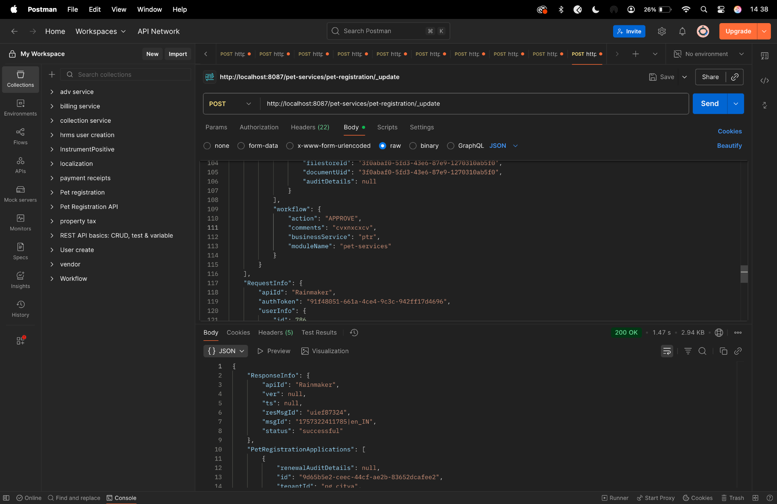

Diff Checker
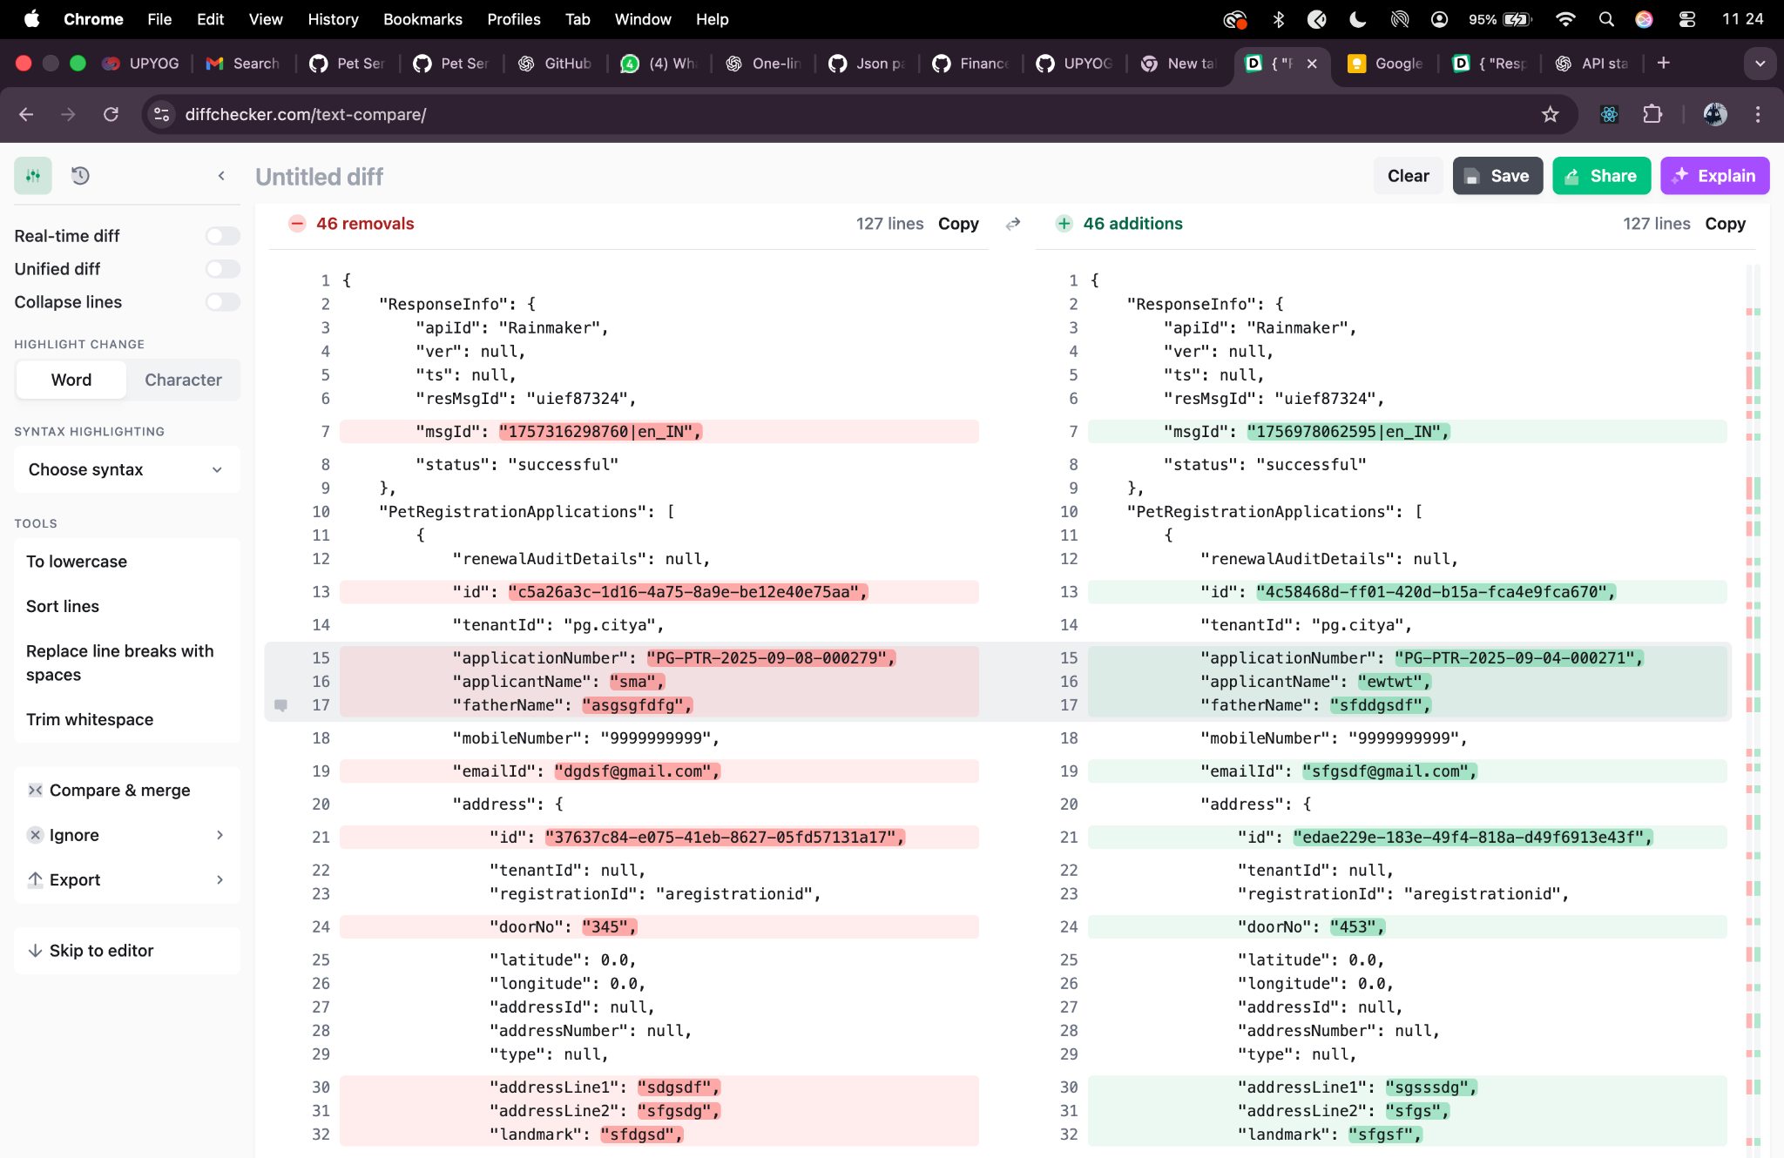

Before Lts update -

Search curl -

curl --location 'https://niuatt.niua.in/pet-services/pet-registration/_search?tenantId=pg.citya&applicationNumber=PG-PTR-2025-09-04-000269&_=1756976187605' \
--header 'accept: application/json, text/plain, */*' \
--header 'accept-language: en-GB,en-US;q=0.9,en;q=0.8' \
--header 'content-type: application/json;charset=UTF-8' \
--header 'origin: https://niuatt.niua.in' \
--header 'priority: u=1, i' \
--header 'referer: https://niuatt.niua.in/digit-ui/employee/ptr/petservice/application-details/PG-PTR-2025-09-04-000269' \
--header 'sec-ch-ua: "Not;A=Brand";v="99", "Google Chrome";v="139", "Chromium";v="139"' \
--header 'sec-ch-ua-mobile: ?0' \
--header 'sec-ch-ua-platform: "macOS"' \
--header 'sec-fetch-dest: empty' \
--header 'sec-fetch-mode: cors' \
--header 'sec-fetch-site: same-origin' \
--header 'user-agent: Mozilla/5.0 (Macintosh; Intel Mac OS X 10_15_7) AppleWebKit/537.36 (KHTML, like Gecko) Chrome/139.0.0.0 Safari/537.36' \
--header 'Cookie: _ga=GA1.1.1281085881.1747741867; _clck=1ggqflr%7C2%7Cfyf%7C0%7C1966; _ga_VZ9TNBTB3X=GS2.1.s1755061755$o5$g0$t1755061755$j60$l0$h0; locale=en_IN' \
--data '{
"RequestInfo": {
"apiId": "Rainmaker",
"authToken": "79d34863-1fe7-4eda-94a1-93d24edd5504",
"userInfo": {
"id": 786,
"uuid": "4b662cf9-18d8-43fb-a532-a955104dd2f8",
"userName": "PET_CEMP",
"name": "Pet",
"mobileNumber": "9810010169",
"emailId": null,
"locale": null,
"type": "EMPLOYEE",
"roles": [
{
"name": "Employee",
"code": "EMPLOYEE",
"tenantId": "pg.citya"
},
{
"name": "Pet Counter Employee",
"code": "PTR_CEMP",
"tenantId": "pg.citya"
},
{
"name": "Pet Document Verifier",
"code": "PTR_VERIFIER",
"tenantId": "pg.citya"
},
{
"name": "Pet Approver",
"code": "PTR_APPROVER",
"tenantId": "pg.citya"
}
],
"active": true,
"tenantId": "pg.citya",
"permanentCity": null
},
"msgId": "1756976187605|en_IN",
"plainAccessRequest": {}
}
}'

Response -

{
"ResponseInfo": {
"apiId": "Rainmaker",
"ver": null,
"ts": null,
"resMsgId": "uief87324",
"msgId": "1756976187605|en_IN",
"status": "successful"
},
"PetRegistrationApplications": [
{
"renewalAuditDetails": null,
"id": "c97942e3-4f81-45a7-8237-6493fcc92438",
"tenantId": "pg.citya",
"applicationNumber": "PG-PTR-2025-09-04-000269",
"applicantName": "twetw",
"fatherName": "wretwrt",
"mobileNumber": "9999999999",
"emailId": "wertwe@gmail.com",
"address": {
"id": "11ccb9be-594a-40c8-9923-fc289643f7f8",
"tenantId": null,
"registrationId": "aregistrationid",
"doorNo": "345",
"latitude": 0.0,
"longitude": 0.0,
"addressId": null,
"addressNumber": null,
"type": null,
"addressLine1": "sgsdg",
"addressLine2": "sdfgsd",
"landmark": "sfgg",
"city": "New Delhi",
"pincode": "112233",
"detail": "adetail",
"buildingName": "Rohini\n",
"street": "sfgsdf",
"locality": null
},
"auditDetails": {
"createdBy": "8ddbbdba-5ce1-4cbd-83a4-c8236f95766e",
"lastModifiedBy": "4b662cf9-18d8-43fb-a532-a955104dd2f8",
"createdTime": 1756965774151,
"lastModifiedTime": 1756976815966
},
"petDetails": {
"id": "13415bfa-d5f1-4348-b911-d41cd1732a34",
"petDetailsId": null,
"petName": "asdfgf",
"petType": "Cat",
"breedType": "Bombay Cat",
"petAge": "1",
"petGender": "MALE",
"clinicName": "sdfgsd",
"doctorName": "sfgd",
"lastVaccineDate": "2025-09-02",
"vaccinationNumber": "453545",
"petColor": "19",
"adoptionDate": 0,
"birthDate": 1754332199000,
"identificationMark": "dfgdg"
},
"applicationType": "NEWAPPLICATION",
"validityDate": 1774981740,
"status": "APPROVED",
"expireFlag": false,
"petToken": "PG-2025-09-04-000073",
"previousApplicationNumber": null,
"propertyId": "34535",
"documents": [
{
"id": "18f6060b-5333-41c6-8288-c81fa077859a",
"active": null,
"tenantId": null,
"documentType": "OWNER.IDENTITYPROOF.PAN",
"filestoreId": "dd6f5fea-e895-4cbb-be28-0dc34e5a66bb",
"documentUid": "dd6f5fea-e895-4cbb-be28-0dc34e5a66bb",
"auditDetails": null
},
{
"id": "66ccd58d-1f47-4b96-8e01-3033e4f02cef",
"active": null,
"tenantId": null,
"documentType": "OWNER.OWNERPHOTO",
"filestoreId": "74e5b7b8-f511-4223-b55f-23af2d75f1cb",
"documentUid": "74e5b7b8-f511-4223-b55f-23af2d75f1cb",
"auditDetails": null
},
{
"id": "3e74a4fd-e0db-4178-b979-dc7737ebf763",
"active": null,
"tenantId": null,
"documentType": "PET.VACCINATIONCERTIFICATE",
"filestoreId": "1ba5ccc8-01aa-4a8a-b549-d2eedd352698",
"documentUid": "1ba5ccc8-01aa-4a8a-b549-d2eedd352698",
"auditDetails": null
},
{
"id": "275fed10-a73e-4fcf-ab2e-ea3fd276a7a4",
"active": null,
"tenantId": null,
"documentType": "PET.FITNESSCERTIFICATE",
"filestoreId": "41d0c574-7082-48d0-9a30-1aa72103a58a",
"documentUid": "41d0c574-7082-48d0-9a30-1aa72103a58a",
"auditDetails": null
},
{
"id": "f94b62a9-1573-4401-a9ca-a65001be87c1",
"active": null,
"tenantId": null,
"documentType": "PET.PETPHOTO",
"filestoreId": "3d6e8ce5-6a59-4892-a4f1-34690753bfd1",
"documentUid": "3d6e8ce5-6a59-4892-a4f1-34690753bfd1",
"auditDetails": null
}
],
"workflow": null
}
]
}

After Lts-

Search curl -

curl --location 'http://localhost:8087/pet-services/pet-registration/_search?tenantId=pg.citya&applicationNumber=PG-PTR-2025-09-04-000271&_=1756977798946' \
--header 'accept: application/json, text/plain, */*' \
--header 'accept-language: en-GB,en-US;q=0.9,en;q=0.8' \
--header 'content-type: application/json;charset=UTF-8' \
--header 'origin: https://niuatt.niua.in' \
--header 'priority: u=1, i' \
--header 'referer: https://niuatt.niua.in/digit-ui/employee/ptr/petservice/application-details/PG-PTR-2025-09-04-000271' \
--header 'sec-ch-ua: "Not;A=Brand";v="99", "Google Chrome";v="139", "Chromium";v="139"' \
--header 'sec-ch-ua-mobile: ?0' \
--header 'sec-ch-ua-platform: "macOS"' \
--header 'sec-fetch-dest: empty' \
--header 'sec-fetch-mode: cors' \
--header 'sec-fetch-site: same-origin' \
--header 'user-agent: Mozilla/5.0 (Macintosh; Intel Mac OS X 10_15_7) AppleWebKit/537.36 (KHTML, like Gecko) Chrome/139.0.0.0 Safari/537.36' \
--header 'Cookie: _ga=GA1.1.1281085881.1747741867; _clck=1ggqflr%7C2%7Cfyf%7C0%7C1966; _ga_VZ9TNBTB3X=GS2.1.s1755061755$o5$g0$t1755061755$j60$l0$h0; locale=en_IN' \
--data '{
"RequestInfo": {
"apiId": "Rainmaker",
"authToken": "3044d66f-38d6-4fcf-8e6e-102c178bd953",
"userInfo": {
"id": 786,
"uuid": "4b662cf9-18d8-43fb-a532-a955104dd2f8",
"userName": "PET_CEMP",
"name": "Pet",
"mobileNumber": "9810010169",
"emailId": null,
"locale": null,
"type": "EMPLOYEE",
"roles": [
{
"name": "Employee",
"code": "EMPLOYEE",
"tenantId": "pg.citya"
},
{
"name": "Pet Counter Employee",
"code": "PTR_CEMP",
"tenantId": "pg.citya"
},
{
"name": "Pet Document Verifier",
"code": "PTR_VERIFIER",
"tenantId": "pg.citya"
},
{
"name": "Pet Approver",
"code": "PTR_APPROVER",
"tenantId": "pg.citya"
}
],
"active": true,
"tenantId": "pg.citya",
"permanentCity": null
},
"msgId": "1756977798946|en_IN",
"plainAccessRequest": {}
}
}'

Response -

{
"ResponseInfo": {
"apiId": "Rainmaker",
"ver": null,
"ts": null,
"resMsgId": "uief87324",
"msgId": "1756977798946|en_IN",
"status": "successful"
},
"PetRegistrationApplications": [
{
"renewalAuditDetails": null,
"id": "4c58468d-ff01-420d-b15a-fca4e9fca670",
"tenantId": "pg.citya",
"applicationNumber": "PG-PTR-2025-09-04-000271",
"applicantName": "ewtwt",
"fatherName": "sfddgsdf",
"mobileNumber": "9999999999",
"emailId": "sfgsdf@gmail.com",
"address": {
"id": "edae229e-183e-49f4-818a-d49f6913e43f",
"tenantId": null,
"registrationId": "aregistrationid",
"doorNo": "453",
"latitude": 0.0,
"longitude": 0.0,
"addressId": null,
"addressNumber": null,
"type": null,
"addressLine1": "sgsssdg",
"addressLine2": "sfgs",
"landmark": "sfgsf",
"city": "New Delhi",
"pincode": "111223",
"detail": "adetail",
"buildingName": "sdfgsdg",
"street": "sgsd",
"locality": null
},
"auditDetails": {
"createdBy": "8ddbbdba-5ce1-4cbd-83a4-c8236f95766e",
"lastModifiedBy": "8ddbbdba-5ce1-4cbd-83a4-c8236f95766e",
"createdTime": 1756966326495,
"lastModifiedTime": 1756966326495
},
"petDetails": {
"id": "a0f9f219-6455-41fe-984e-7484df71e682",
"petDetailsId": null,
"petName": "ssdgsd",
"petType": "Cat",
"breedType": "Bombay Cat",
"petAge": "2",
"petGender": "MALE",
"clinicName": "sgs",
"doctorName": "sg",
"lastVaccineDate": "2025-09-02",
"vaccinationNumber": "4335345",
"petColor": "18",
"adoptionDate": 0,
"birthDate": 1751394599000,
"identificationMark": "sfgs"
},
"applicationType": "NEWAPPLICATION",
"validityDate": 1774981740,
"status": "APPLIED",
"expireFlag": false,
"petToken": "",
"previousApplicationNumber": null,
"propertyId": "4353",
"documents": [
{
"id": "683a17bb-043a-40d9-8d6b-1749777fcecd",
"active": null,
"tenantId": null,
"documentType": "OWNER.IDENTITYPROOF.AADHAAR",
"filestoreId": "3bc4f5e2-198d-46d1-8aa5-9364d61449c3",
"documentUid": "3bc4f5e2-198d-46d1-8aa5-9364d61449c3",
"auditDetails": null
},
{
"id": "df27e2ac-e426-4611-ada7-6b79fb6b7bef",
"active": null,
"tenantId": null,
"documentType": "OWNER.OWNERPHOTO",
"filestoreId": "032dd3d5-7c94-4edb-8725-518c0795904c",
"documentUid": "032dd3d5-7c94-4edb-8725-518c0795904c",
"auditDetails": null
},
{
"id": "f1e47d3a-0b2d-4047-8096-572183f3ec60",
"active": null,
"tenantId": null,
"documentType": "PET.VACCINATIONCERTIFICATE",
"filestoreId": "2e16c3a0-d9c0-4ec2-8f2c-bf60f791c1b0",
"documentUid": "2e16c3a0-d9c0-4ec2-8f2c-bf60f791c1b0",
"auditDetails": null
},
{
"id": "46fb0df6-5afd-4bf9-b87b-80af8441a347",
"active": null,
"tenantId": null,
"documentType": "PET.PETPHOTO",
"filestoreId": "d7106ce3-e157-402f-bc19-00df51e3e8e4",
"documentUid": "d7106ce3-e157-402f-bc19-00df51e3e8e4",
"auditDetails": null
},
{
"id": "584b5c43-d4fe-4f9b-9fa0-8991dbc9c2cf",
"active": null,
"tenantId": null,
"documentType": "PET.FITNESSCERTIFICATE",
"filestoreId": "43ad10b1-7f4c-4be9-a2c5-3201d3eaf91c",
"documentUid": "43ad10b1-7f4c-4be9-a2c5-3201d3eaf91c",
"auditDetails": null
}
],
"workflow": null
}
]
}

Postman -
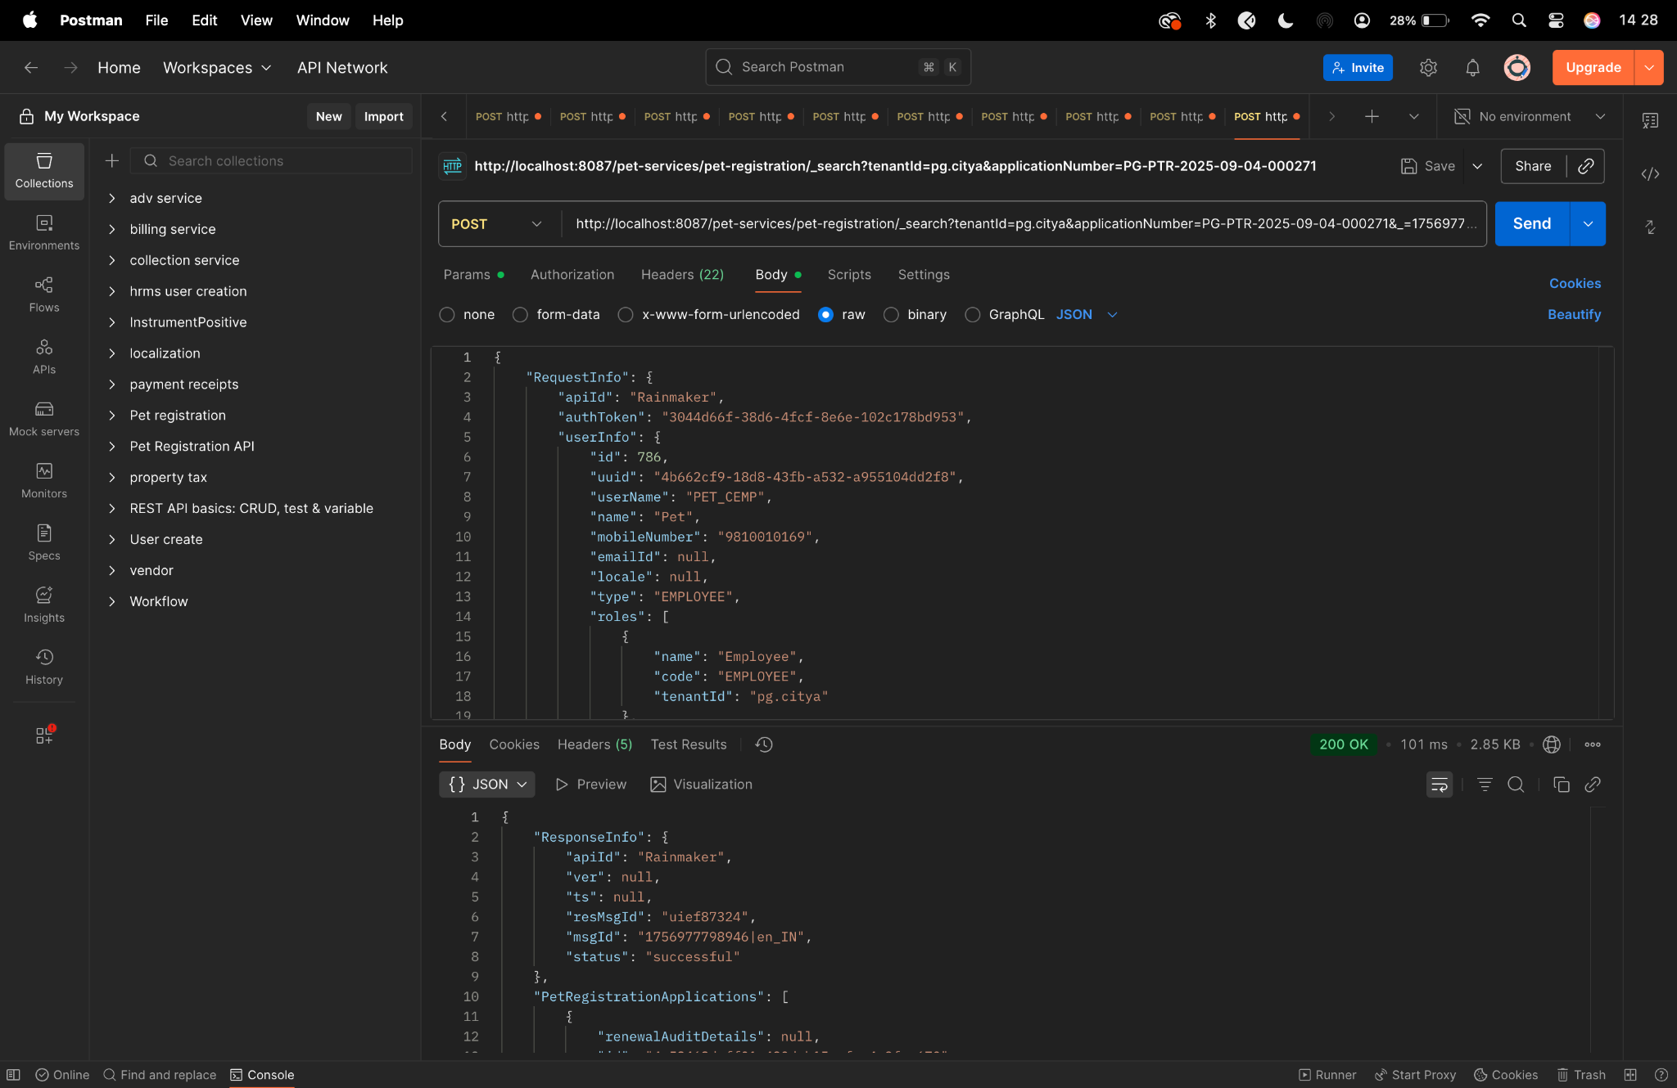

Diff checker -
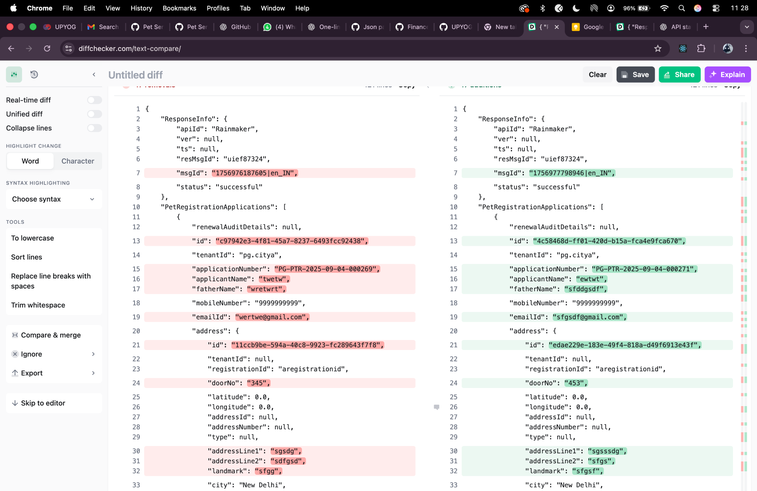

Trigger-expire-petapplications

Curl -

curl --location --request POST 'http://localhost:8087/pet-services/pet-registration/trigger-expire-petapplications' \
--header 'accept: */*'

Response -

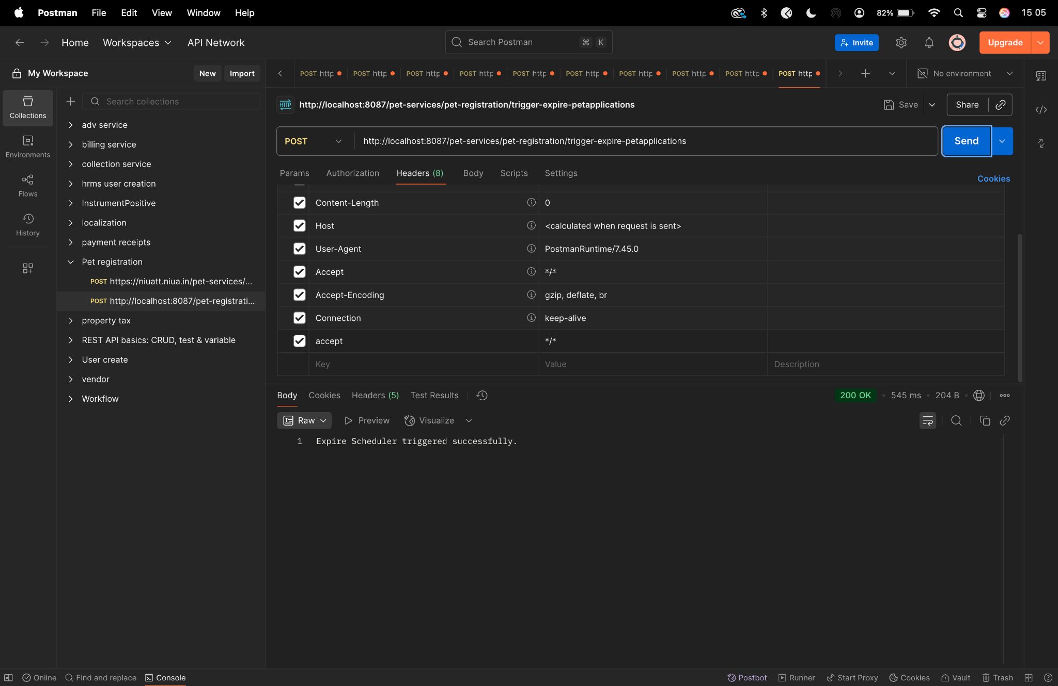

Trigger-advance-notification

curl --location --request POST 'http://localhost:8087/pet-services/pet-registration/trigger-advance-notification' \
--header 'accept: */*'

Response -
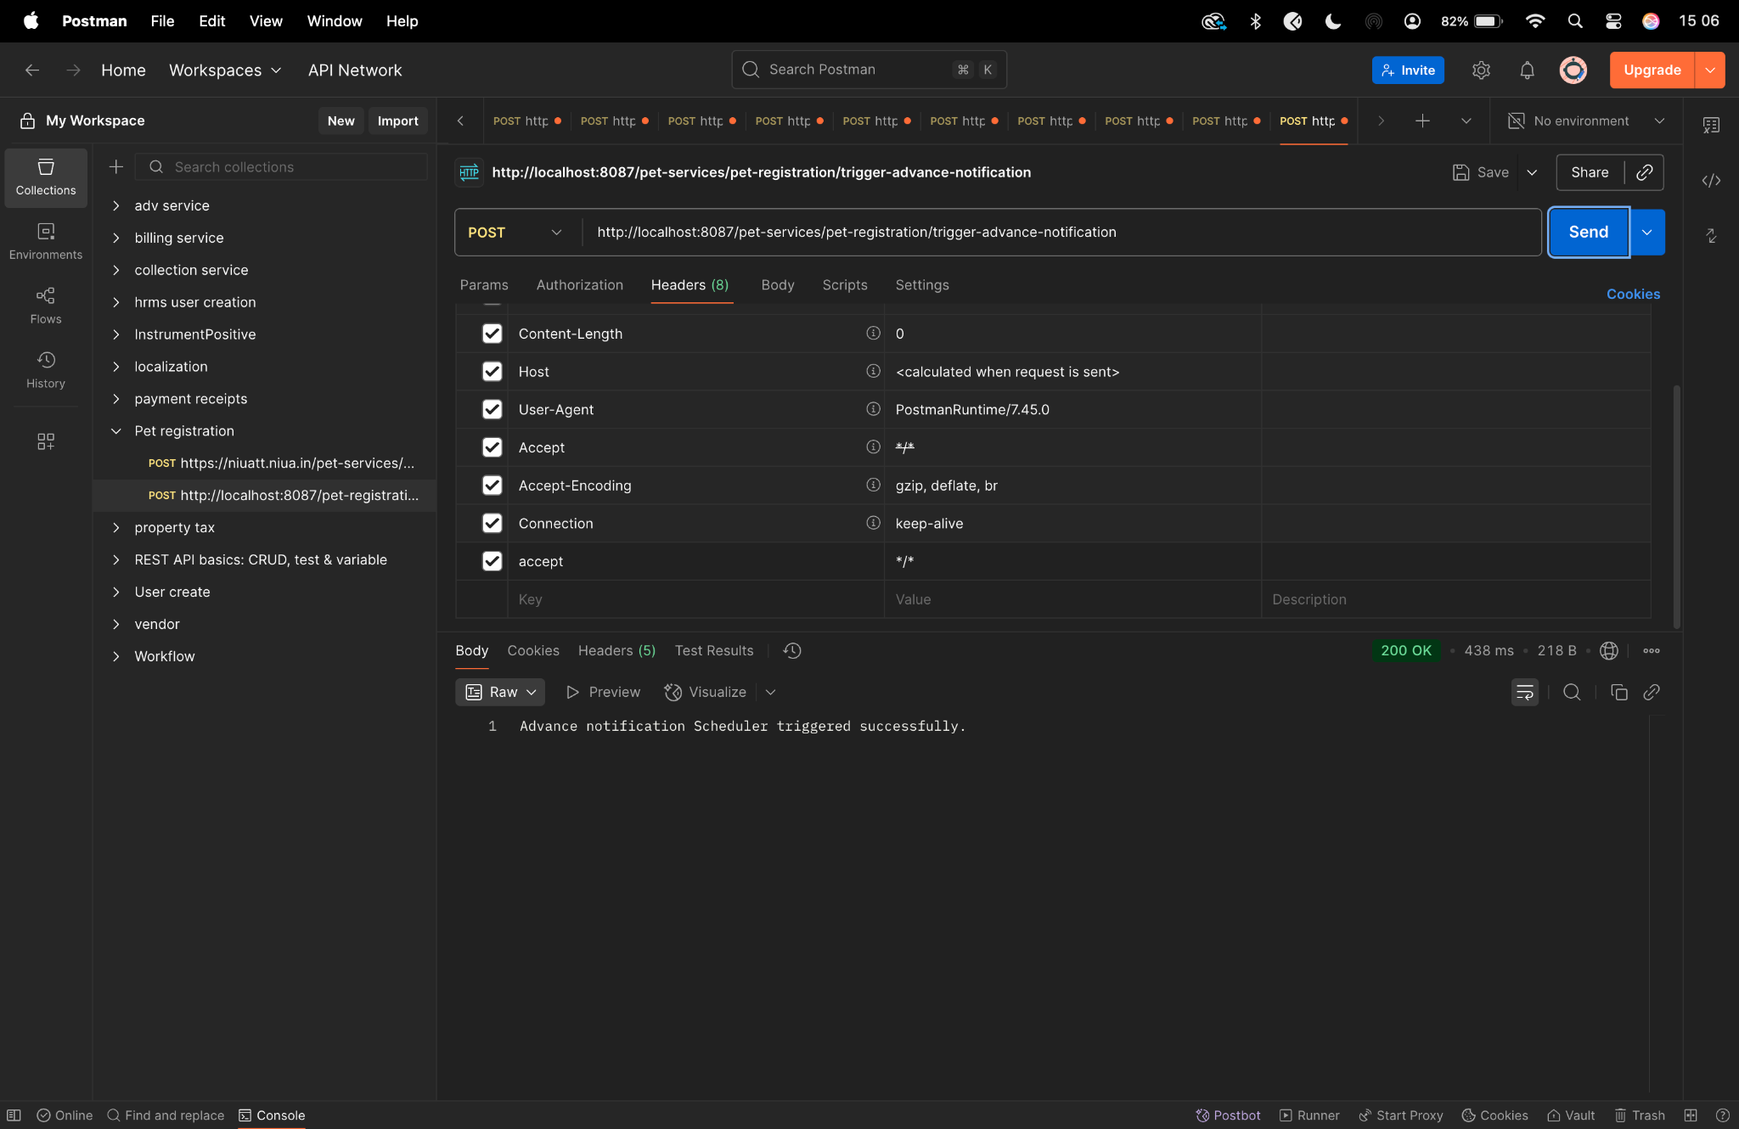

curl --location --request POST 'http://localhost:8087/pet-services/pet-registration/trigger-advance-notification' \
--header 'accept: */*'

